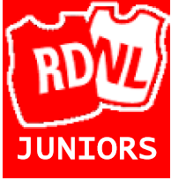

**RDNL Junior Emergency Contact Details**

RDNL Junior Netball does not accept any responsibility for any injury or damage sustained to any individual or their property during their training sessions or matches.

I agree to coaches of RDNL Junior Netball giving permission for my child to receive appropriate medical treatment in an emergency and/or to treat her for minor injuries during her training session.

Signed:_______________________________________ Date:______________

Relationship to Child: Parent/Guardian

Please provide emergency contact details for your daughter.

This must be someone who is contactable throughout the time of your daughter’s training session.

Contact 1

Name……………………………………………………………..

Contact telephone number……………………………………..

Relationship to your daughter…………………………………..

Contact 2

Name……………………………………………………………….

Contact telephone number……………………………………….

Relationship to your daughter……………………………………